**Change Request**

**User Guide**

|  |  |
| --- | --- |
|  | **Users** |
| 1 | Change Analyst |
| 2 | Approver |
| 3 | Support Engineer |

**Note:**

1. An Analyst/Master is capable of initiating and Closing a Change Request.
2. An Approver is authorized solely to approve the various levels..
3. A Support Engineer is responsible for implementing a specified number of tasks.

**Login Page**

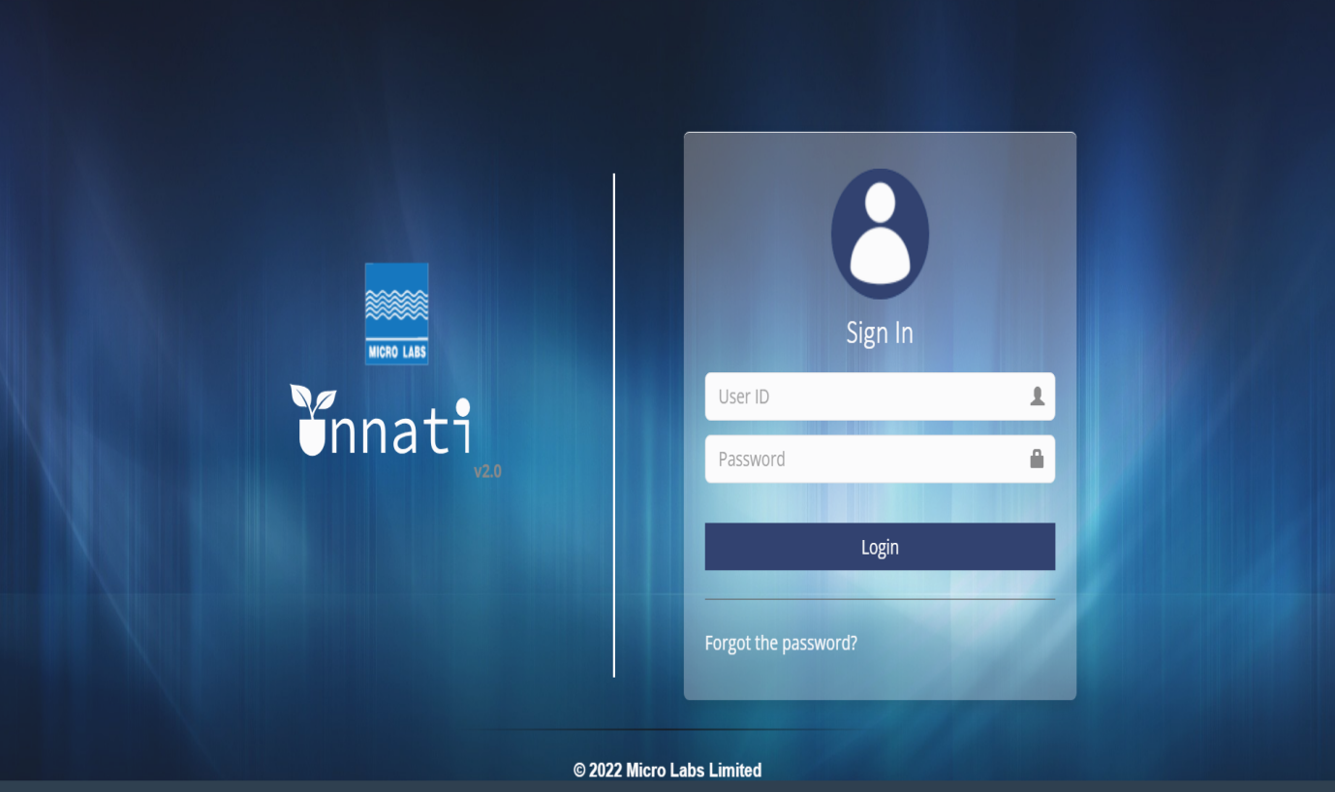

**Steps to be followed:**

1. Login as an Analyst to Create a Change request.

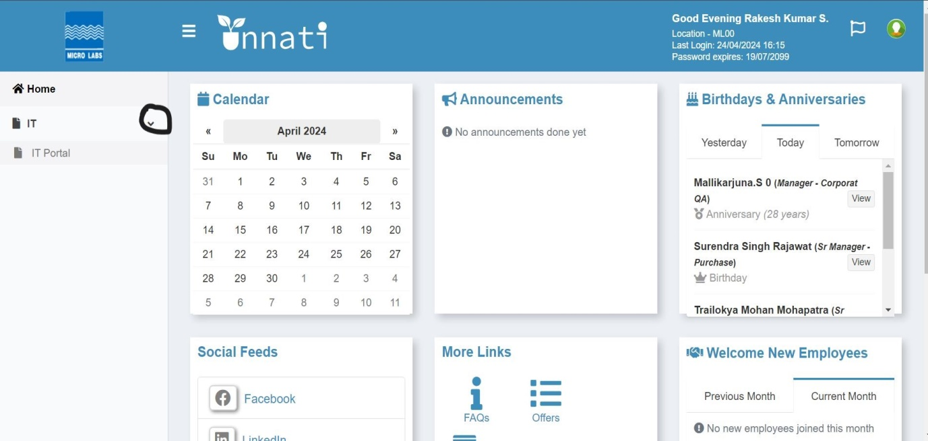

1. Click on IT on the Dropdown and click on IT Portal.

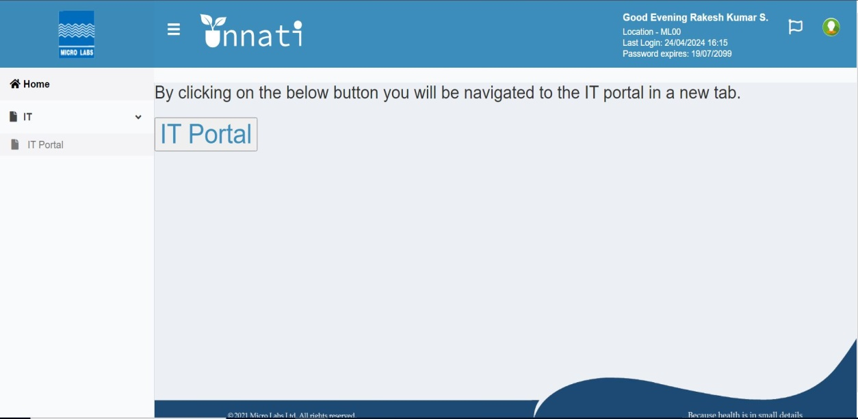

1. Click on IT Portal Button.